**Master Functional Document**

|  |  |
| --- | --- |
| **Application** | NGERP - Centra |
| **Service Bundle** | Master Management |
| **Service Request** | Transaction Group Config |

**Description :**

Transaction Group Config Masters is used to give window access and group acces to the user. If a transaction group is not active the system will not show the window or partner group.

**Workflow Process :**

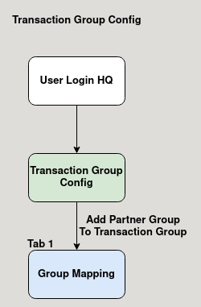

**Business Rules :**

* User showld login HQ to edit transaction group config.
* User can activate or deactive a window in the master.
* User add a partner group in the group mapping tab in the transaction group config master.
* User can also activate or deactivate the user group in the group mapping tab.